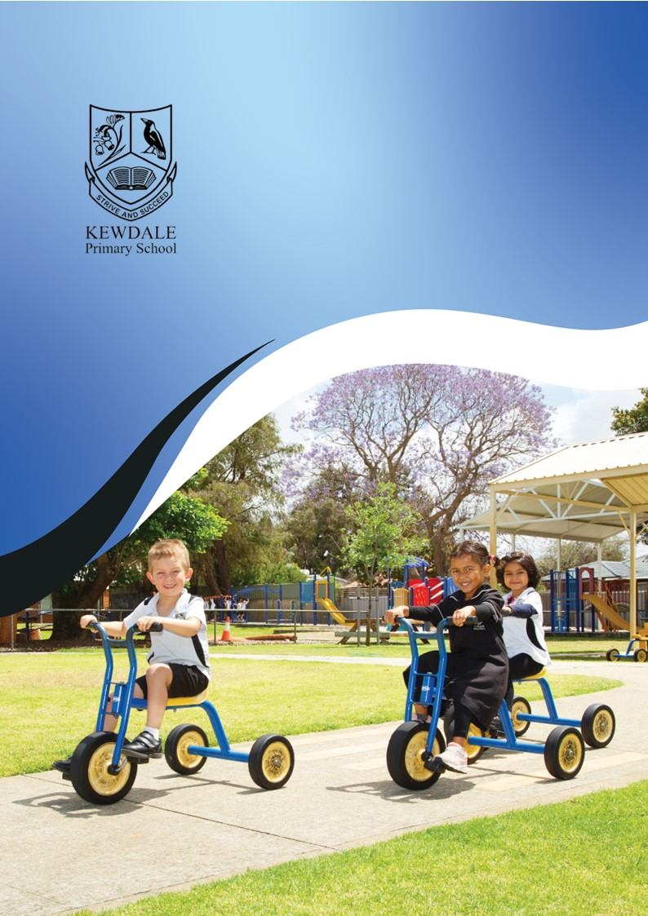

Early Childhood Information Booklet

**Principal’s Welcome**

Welcome to Kewdale Primary School. I am absolutely delighted that you chose to partner with Kewdale Primary School to commence what I hope will be a wonderful lifelong journey with learning and education.

I am privileged to be Principal of Kewdale Primary School and welcome your association with our school. I am deeply committed to fostering a nurturing environment in which every child is supported to flourish. We look forward to working together to make these years of education a rewarding experience for your child.

Kewdale Primary School, established in 1915, has a long history of academic excellence, community support and the provision of a wide range of opportunities to develop the skills, interests, and knowledge of all children in our care. We believe there is a unique culture at Kewdale and this community spirit is evident immediately when walking into Kewdale Primary School. Students, staff and parents actively participate in establishing Kewdale Primary School as the pillar of the community that it has become and are proud to invoke a sense of belonging and a lifelong association with the school. Students build their future upon the foundations that Kewdale Primary School has provided.

The school community through the School Council plays a pivotal role in reviewing the school’s strategic direction. Our active and dedicated Parents and Citizen’s Association work in partnership with the school community to promote our learning programs and school in the wider community. The challenge for schools is to meet the individual needs of all learners, unlocking the talents, gifts and potential of every student with who’s successful development we’re entrusted. We support parents in wanting the very best for their children. Working together we can achieve success which results in lifelong learning. At school, we build on the foundation laid by parents, and we encourage parents and carers to become actively involved in school life.

Kind regards

Tracey Irving

Principal

Kewdale Primary School

**Early Childhood Philosophy**

The Kewdale Primary School Early Childhood Education Statement of Philosophy underpins the principles and beliefs under which our early childhood operates from kindergarten through to Year 2. Our Statement of Philosophy reflects the values, beliefs, and practices of Kewdale Primary School, the principles of the National Quality Standard for Early Childhood Education, the Early Years Learning Framework, the Western Australian Curriculum, and the Kindergarten Curriculum Guidelines. It guides the decisions, policies and daily practices of all staff working within the early years at Kewdale Primary School and assists in planning, implementing, and evaluating quality experiences for our students. Our Statement of Philosophy supports consistency and continuity in working with our students, their families, and our broader community. It will guide the development of shared, common, and clear goals and will help create a unified team that embodies our values of respect, kindness, and resilience.

**Our Place**

Kewdale Primary School was established in 1915 with early childhood education being an integral part since the closure and amalgamation of Kewdale Junior Primary in 1996. It has a long history of community support and the provision of a wide range of opportunities to develop the skills, interests, and knowledge of all children in our care. We foster a nurturing and inclusive environment for all children. We embrace diversity, acknowledging that learning begins at home. We work closely with families to create a safe, engaging learning space. Our classrooms encourage exploration, creativity, and growth, providing opportunities for all children to thrive and feel a sense of belonging. The unique culture at Kewdale Primary enhances the community spirit which is evident immediately when walking into our School. We value our community, its expectations, hopes, dreams and aspirations. Students, staff, and parents actively participate in establishing Kewdale Primary School as the pillar of the community and we are proud to invoke a sense of belonging and a lifelong association with the school.

**Our Beliefs**

We believe that every child is a capable, competent learner, developing in different ways at their own pace. All children deserve equal opportunities to grow academically, socially, and emotionally through a focus on explicit teaching, supported by intentional play-based learning experiences. Learning is best achieved when children are engaged, supported, and challenged, and when their individual strengths, interests, and cultural backgrounds are respected and celebrated. We value the collaborative efforts of teachers, specialists and parents, in providing holistic support for each child.

**Our Commitment**

We are committed to delivering high-quality education through a range of teaching strategies. Teachers set high expectations for every child, ensuring they progress regardless of their starting point. Using differentiated instruction and regular assessment, we tailor learning experiences to ensure each child receives holistic learning experiences to ensure progress for each student. We work collaboratively to meet each child’s unique learning needs and ensure that all children make academic and personal progress. We recognise and value the knowledge and commitment of our teachers and assistants and support their continued professional learning. We believe in the importance of working as a united team in order to support each other professionally.

**Our Goal**

Our goal is to develop confident, independent learners who are equipped with the skills to succeed. We aim for every child to make at least 12 months' progress each year by providing structured, intentional teaching in literacy, numeracy, and social-emotional skills. Through ongoing feedback, monitoring, and differentiation, we ensure each child receives the necessary support and challenge to reach their full potential.

**Our Intention**

Our intention is to create a balanced, engaging curriculum that inspires a love of learning. We strive to integrate a solid foundation of explicit teaching with inquiry-based learning, offering children a variety of opportunities to explore, question, and solve problems in meaningful ways. By nurturing a sense of belonging and responsibility, we guide children to become active, reflective learners who are prepared for future academic and social success.

**Times**

Establishing an arrival pattern to school as part of a morning routine is very important to help your child to settle into classroom life successfully. This is necessary for your child’s entire school life and work life beyond.

Doors open at **8.35am**

School starts at **8.50am**

School ends at **3.10pm**

**Kindergarten**

Kindergarten is 15 hours a week. At Kewdale, we offer this as a 5-day fortnight. With students attending Thursday and Friday alternating Wednesdays. Although Kindergarten is a non-compulsory year, once your child is enrolled, attendance is extremely important.

**Pre-Primary**

Pre-Primary is your child’s first compulsory year of school and students attend 5 days a week.

**Delivering and Collecting Children**

For the children’s safety, it is most important that children arriving at school are accompanied by an adult to the classroom, into the teacher’s care. Likewise, children need to be collected by carers at the classroom door. Those under the age of 18 are not allowed to collect Kindergarten and Pre-Primary children. If you wish for a person under the age of 18 to collect your child, you must put this in writing to the principal. If you have planned for another adult to collect your child at the end of the day, please make sure you fill out the “Communications Book” in the classroom. We will not dismiss your child to any adult without parental consent. Authorisation may also be given by phone (on the day) by phoning the school office on 9473 9500. Also, we ask that if you are delayed at any time and are unable to collect your child on time, please notify us by phone so that we can let your child know.

**Attendance**

Regular attendance at school is necessary for maximum learning.

**Absences**

If your child is going to be away from school please inform the teacher in advance, if possible, or ring the school in the morning before 9.15am, as an SMS is automatically generated if you have not notified the school of your child’s absence.

**Holidays During Term**

Department of Education policy does not encourage parents taking children out of school during term. However, if you are planning to go on holiday during this time, please provide a letter to the Principal, stating the dates you will be away, where and why you are taking holidays.

**Arriving Late**

If you arrive after 8.55am it is school policy that you sign in at the front office and pick up a late note, before bringing your child to the class.

**Leaving school**

If you need to pick your child up before the end of the school day, you will need to go through the front office and obtain a note before collecting child from the classroom.

**General School Information**

**School Development Days**

The whole school is closed during School Development Days when all teachers are involved in Professional Learning. The dates are advised through the school newsletter, Term Planners and the Schools Website.

**Parents’ and Citizens Association**

Kewdale Primary School has a strong P&C Association that has provided many school facilities and resources. New members are welcome at meetings which are held twice a term. The P&C have a Facebook page: “Kewdale Primary P&C” where information updates are posted regularly. Parents are encouraged to become members at the Annual General Meeting which is generally held in the first few weeks of Term 1.

If you are interested in helping our school community, please email the P&C president; president@kewdalepnc.org.au

**School Contribution**

 The school contribution is $60 per child plus a $10 P&C Family Contribution. These payments can be made at the school office, or through the School Booklist.

**Money to School**

Money for book club, incursions, excursions, fundraising, etc, must be placed in an envelope (available from the office) and placed in the school or P&C letterbox in the front office. Eftpos facilities are also available for certain payments.

**Keeping Informed**

Kewdale Primary School has a number of ways you can keep informed about important dates and events.

* school website [www.kewdaleps.wa.edu.au/](http://www.kewdaleps.wa.edu.au/)
* school newsletter through Connect
* compass
* School Facebook page
* P&C Facebook page “Kewdale Primary P&C”

**Parent Communication**

If you have any concerns about your child, please come in and see the teacher. Problems or worries that seem very big can be more easily addressed if the teacher is able to partner with families to resolve them.

**Booklists**

Kindergarten and Pre-primary have a School Requirements List. Please name your child’s library bag, hat and uniforms. There is no need to coverany booksas these will be covered with the children’s artwork. There will be no need to name pencils, glue or crayons.

**Contact Details**

Please inform the office if you change:

1. Home phone number, mobile phone number or address.

2. Either parent’s workplace and/or phone number.

3. Emergency contacts

4. If there are any legal limitations (or pending) please provide all documentation

to ensure you and your child’s safety.

5. Medical details – if your child has a medical condition, please provide all

documentation so we can help and support your child.

**School Chaplain and School Nurse**

The school has access to a school chaplainwho is available two days a week to support children and parents who may be experiencing a difficult time in their lives and need someone to talk to. Speak to your teacher or the front office if you feel your child may be in need of this assistance.

The school nursevisits the school to complete health assessment checks on children in Kindergarten and Pre-Primary throughout the year.

**Infectious Diseases**

There are a few common infectious diseases that your child may contract. If you are unsure about sending your child to school with a particular illness, please contact the school and/or your doctor for further advice.

**Toileting**

Learning to toilet independently is part of a child’s personal and social learning and development. **It is expected that children will be toilet trained before they begin Kindergarten.** Most children should be toilet trained by 3 ½ years of age, unless there is an underlying medical condition. More information on toilet training your child is available through the Child Health Development Service.

We understand that children in the early childhood phases of schooling may have toileting accidents. Toileting accidents are handled in a sensitive way to minimise feelings of embarrassment. Please provide a spare change of clothing, including underwear and socks in your child’s bag. Please refer to the Toileting and Hygiene Policy.

**Head Lice**

Head lice occasionally infect students’ hair. This is not a reflection on the child or family but must be treated. Information on the treatment of head lice is available at the front office/chemist/Health Department website:

healthywa.wa.gov.au/Articles/F_I/Head-lice

**Sickness**

|  |  |  |  |  |  |  |  |
| --- | --- | --- | --- | --- | --- | --- | --- |
| **I NEED TO STAY HOME IF** | | | | | | |  |
| **I have a Fever** | **I am Vomiting** | **I have Diarrhoea** | **I have a Rash** | **I have Head Lice** | **I have an Eye Infection** | **I have a Runny Nose** | **I have a Persistent Cough** |
|  |  |  |  |  |  |  |  |
| Temperature of 38 degrees or higher | Within the past 24 hours | Within the past 24 hours | Body rash with itching or fever | Itchy head, active head lice | Redness, itching and/or “crusty” drainage from eye | With yellow/ green discharge | Croupy cough |
| **I’m Ready to Go Back When I Am** | | | | | | |  |
| Fever free for 24 hours without the use of fever reducing medication (i.e. Panadol, Nurofen, etc) | Free from vomiting for at least 2 solid meals | Free from Diarrhoea for at least 24 hours | Free from rash itching or fever. I have been evaluated by a doctor if needed | Treated with appropriate lice treatment at home. | Evaluated by my doctor and have a note to return to school | On required antibiotics for 24 hours | Cleared by my doctor and have a note specifying my continued symptoms are not contagious |

The best place for a sick child is at home. Should your child become unwell at school, we will contact you to collect them.

**Accidents at School**

Kewdale Primary School has no less than three (3) staff trained in First Aid. Should your child be injured during school time, teaching staff shall render first-aid and contact parents should this be considered necessary by our First-Aid Officer. We will always endeavour to communicate with you when accidents occur at school.

**Nut Aware School**

Anaphylaxis is a life-threatening allergic reaction to certain foods. At times, some children and staff at Kewdale are highly allergic to peanuts and nut products.  If they come into contact with peanut or peanut extract, they will have an anaphylactic reaction to it. Tasting, touching and smelling peanuts is enough to trigger such a reaction*.* Please ensure that children do not come into school with any traces of peanut on their hands and face. **Please do not send to school nuts or food that clearly contains any type of nut product e.g. peanut butter, Nutella.**

**Medication Administration at School**

j0232137The importance of not sending sick children to school if they require medication not only helps your child, but it can also prevent the transfer of infections. Teachers are not legally qualified to administer medications, which is a valid concern for the safety of the children. Instead, parents or guardians should complete a ‘Student’ Medication Request’ form available from reception if your child needs to take medication during school hours, even if the child is capable of self-administering. This aims to ensure the safety and wellbeing of the students while also respecting the limitations of teachers in terms of medical responsibilities. It also emphasizes the importance of correct documentation and communication between parents and the school when it comes to administering medications.

**Immunisation Records**

Children enrolling in kindergarten must be up to date with all scheduled immunisations for their age to be able to attend school. You will need to show your child’s **Australian Immunisation Register (AIR) Immunisation History Statement** as proof of immunisation. Once your child has had their 4-year-old Diphtheria, Tetanus, Whooping Cough, Poliomyelitis administered, please supply the updated AIR to the school office.

**Re-enrolling for Pre-Primary**

As Kindergarten is not compulsory, children will need to be re-enrolled for Pre-Primary for the following year. This can be done by visiting the school office in the second half of the year (through to the end of Term 3). An “up to date” AIR Statement, dated no more than 6 months ago needs to be presented to complete your re-enrolment.

**Leaving for another school**

Please advise your child’s teacher and the school office as soon as possible.

**What Your Child Will Need**

**School Uniform**

Our school strives to ensure it has a school culture where students feel proud to belong to Kewdale Primary School. The School Dress Code is part of enrolment at Kewdale Primary School. The school uniform is available from the P&C School Uniform Shop based on-site. Opening times are Fridays from 8.30-9am. Second-hand uniforms are available.

**Hat**

Please supply your child with a broad brimmed hat that can be left at school. No caps. We have a strict “no hat, no play” in the sun policy. Children must wear a broad-brimmed hat for all outdoor activities throughout the year, which includes recess and lunch. You can purchase a school hat with our logo from our uniform shop.

**Items include:**

* Short sleeved white polo shirt
* Long sleeved white polo shirt
* School dress
* Black skirt, formal shorts, sport shorts, skorts
* Black tracksuit top
* Black tracksuit pants (available from other stores)
* Short sleeved Faction Polo: red, blue, green, yellow (available from other stores)
* School hat

Paint shirts are provided, however at times your child may come into contact with paint whilst not wearing a protective shirt.

**Footwear:**

Please send children to school in enclosed shoes, sneakers, or a well-covered sandal with backstrap.As the children empty their shoes of sand three times a day, we ask that the children have velcro and not shoelaces.

**Headwear:**

* School broad-brimmed sunsmart hat in black
* One piece hijab (black or white)
* School scrunchies, headband, clip or coloured to match faction colours are available at the uniform shop.

**Spare Clothes**

Younger children sometimes have toileting accidents; therefore, it is a good idea to keep a change of clothing, including underwear in your child’s bag. This will minimize the need to ring you to bring a fresh set of clothes to school.

**Water Bottle**

A water bottle with water only. Please no cordial, juice or milk. This will be kept in the classroom so that the children can access it during the day.

**Lunchbox**

We strongly recommend the use of an insulated lunch bag with freezer block, particularly during the hot months. It is important children can open and shut their lunchboxes and be able to open food packaging. Please write your child’s name on their lunchbox, water bottle and any other containers.

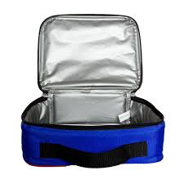**We are not able to keep the children’s**

**lunches in the fridge or heat**

**lunches in the microwave.**

**Fruit**

Your child will need a whole piece of fruit or vegie sticks (each day) to encourage good nutrition, healthy teeth and speech development. Children will eat their own piece of fruit, it will not be cut up and shared.

**Recess**

We have recess from 11.05-11.25am. Children will need a nutritious snack e.g. yoghurt (with a spoon), a piece of fruit, crackers and cheese, vegie sticks and dip, healthy muffin, etc.

**Lunch**

We have lunch from 1.25 – 2.05pm. Children will need a sandwich or rice or noodles. Please provide utensils to eat. We promote healthy eating at the school and suggest a healthy lunch.

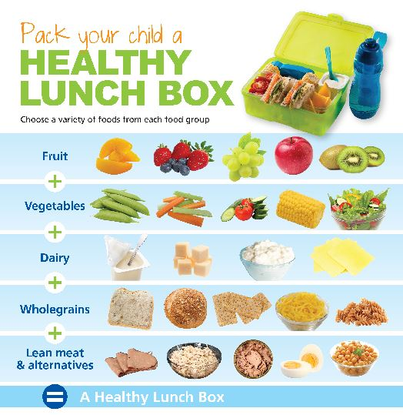

**Please note, no fast foods, lollies / sweets, chocolates or nuts**.

Lunches may be ordered at the Deli and these are delivered to the school.

**Birthdays**

If you wish to send cupcakes on your child’s birthday, please check with the teacher for any allergies and number of students in the class. We ask that you make individual cupcakes as these are easier for little hands. Please do no send in large cakes, lolly bags or party hats.

**Toys and Valuables**

Please don’t bring toys or valuables to school as they may get lost or broken.

**Library**

Children must have a library bagto borrow a book from the library. Library bags are available to purchase from the Uniform shop. Books are borrowed for one week and must be returned before they can borrow another book. It is expected where a loss or irreparable damage has occurred that parents reimburse the library for the loss before another book is allowed to be borrowed.

**Hints for Stress Free Early Days**

The first day of school is a big event in your child’s life and that of your family. To make the most of the day and enjoy the experience, here are some useful tips.

* Avoid big build ups as the unknown can be daunting.
* Talk about the first day but do not push conversation if your child is unsure.
* Bring your child to the school in the days leading up to the beginning of school.
* Have your child practise opening and closing their school bag and lunchbox.
* As hard as it is, try to avoid prolonged goodbyes! If your child is getting upset, reassure them you will be back on time to pick them up and then leave. A prolonged goodbye only escalates the tears. Children usually settle quickly, and we will always call to let you know how they are going!
* Talk Positively about school.
* Have a set routine for going to bed, making sure they get 10-13 hours of sleep a night.
* Have their uniform and school bag ready the night before.
* Pick them up on time.

**KEWDALE PRIMARY SCHOOL**

**264 Kew Street**

**Kewdale 6105**

**Telephone: 9473 9500**

**Email: kewdaleps@education.wa.edu.au**

**Check us out on Facebook**

**Download the School Compass app to keep up to date with notices.**

